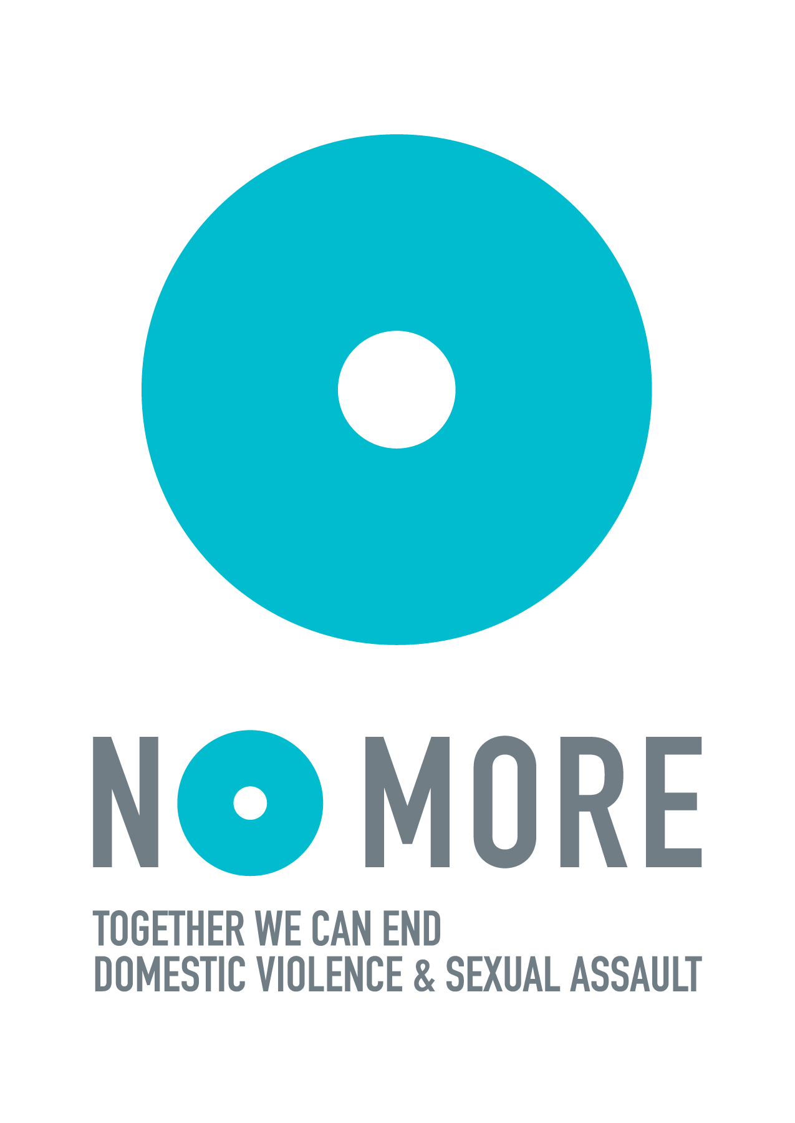

GUIDE TO REQUESTING A #NOMOREWEEK PROCLAMATION

In this guide, you will find:

- How To Request A Mayoral Proclamation
- Steps To Request A Proclamation
- Sample Outreach Email
- Sample #NOMOREweek Proclamation
- Sample Press Release

HOW TO REQUEST A MAYORAL PROCLAMATION

What is a Mayoral Proclamation?
Proclamations are typically issued by a Mayor (or other comparable township leaders) to recognize the importance of a community event, significant achievements by community members, or to signal a City’s role in significant national events.

Proclamations may be read at a City Council meeting, or at an appropriate community event, depending entirely on the schedule of the Mayor. Proclamations are often posted on the City’s website. Original signed proclamations will be provided to the requesting party (sometimes they must be received in person at City offices).

Why request a Mayoral Proclamation?
- Opportunity to meet/greet/photo with your Mayor and/or other City representatives
- Become a NO MORE Ambassador for your City
- Inspire awareness and action to help end domestic violence and sexual assault in your City
- Get your City government more involved in ending domestic violence and sexual assault
- Get more exposure for your organization

What will participation in NO MORE Week offer your City?
- The chance for citizens to give back to their community
- Build and strengthen partnerships across sectors
- Share your City’s commitment to ending domestic violence and sexual assault with new audiences and bring attention to advocates and organizations in your City

STEPS TO REQUEST A PROCLAMATION

Visit your local government’s website.
Some City and State websites will have a section on “How to request a Mayoral Proclamation.” Some will even have an online Mayoral Proclamation Request section on their website. If they do not have an online request section, send an email request to your Mayor; most Mayors will have their contact information, including their email address on the City’s official web page.

Plan ahead.
Proclamations requested in advance have the best chance of being completed and provided to the requestor by a specific date. Ideally, reach out one to two months in advance.
You can use the sample outreach email in this toolkit.

Provide a draft.
If the response is positive from your Mayor’s office, they may request you send sample proclamation language. At the very least, it should be inclusive of DV, SA and all the local organizations working on these issues in your community.
We’ve included a sample draft proclamation in this email for you to edit and send.

Celebrate your city.
Your local government office may invite you to attend a meeting to accept the proclamation in honor of NO MORE Week. This is a great way to bring your community together to celebrate the movement to end domestic violence and sexual assault, as well as a terrific media opportunity. Consider working with other DV/SA agencies and partners to plan a community event. Also, we encourage you to invite local members of the press to take part as well to help spread the message even further.

Share your proclamation.
Share your press release, photos, videos, and other moments from receiving your proclamation with the global NO MORE community on social media by tagging @NOMOREorg and by emailing us your photos, announcements, and copy of your proclamation at info@nomore.org so we can promote your efforts.

SAMPLE OUTREACH EMAIL
[Date]
Honorable [Name]
[Official Title]
[Mailing Address]

Dear [Name]: March 5th - 11th is NO MORE Week, an annual awareness week when more than 73,000 advocates and 1000 allied organizations join together to generate awareness and year-round action for the for the prevention of domestic violence and sexual assault.
This week provides an excellent opportunity for our [City/County/State/School] to demonstrate its support in ending domestic and sexual violence, and to support the numerous survivors who are among us. Moreover, these issues are hidden and chronically under-funded, so this week is a wonderful opportunity to educate the public [or students] of the urgency and the prevalence of this epidemic in our lives.
[Your organization] would be honored if you would sponsor an official proclamation to recognize March 5-11, 2017 as a [City/County/State/School]-wide week of action, joining our [City/County/State/School] with the national effort to end domestic violence and sexual assault.
Your proclamation would lend official recognition to the important work of educating the public on domestic and sexual violence, as well as emphasize your personal commitment to ending this crime.
I have enclosed a sample proclamation which may help your office compose the appropriate proclamation for our [City/County/State/School]. [Insert the following paragraph if you are sponsoring a public awareness event.] [List of organizations] are sponsoring [describe event] on [day] at [time] at [location].
We hope you will attend this special event to present your proclamation. If you are unable to attend, we ask that you or your official representative read the proclamation to our supporters on [day of the event]. If you, or your staff, have any questions concerning the request, the sample proclamation, or NO MORE Week, please call me at [telephone number]. I will follow-up with your office on this request in the next few days.
As always, we appreciate your support of [Your organization] and the national NO MORE campaign, and we are grateful for your commitment to raising visibility for these critical public health issues. Thank you for consideration of this special request.
Sincerely,
[Name]
[Title] Enclosure

SAMPLE PROCLAMATION

RESOLUTION NO._________
RESOLUTION OF THE BOARD OF SUPERVISORS OF THE COUNTY OF [XYZ] PROCLAIMING THE WEEK OF MARCH 5-11, 2017 “NO MORE WEEK”

Whereas, 1 in every 3 women will experience domestic violence during her lifetime; 1 in every 4 women will experience sexual assault in her lifetime; and 1 in 6 men have had abusive or unwanted sexual experiences in their lifetime;

Whereas, approximately 15.5 million children are exposed to domestic violence every year;

Whereas, when a family member is abused, it can have long-term damaging effects on the victim that also leave a mark on family, friends, and the community at large;

Whereas, families are indispensable to a stable society, and they should be a place of support to instill responsibility and values in the next generation;

Whereas, violence against women and children is a prevalent social ill due to the historical imbalance of power in gender and age; however, sexual and domestic violence are widespread and are devastating to society as a whole;

Whereas, the problems of sexual and domestic violence are not confined to any group or groups of people, but crosses all economic, racial, gender, educational, religious, and societal barriers, and are sustained by societal indifference;

Whereas, the crimes of domestic and sexual violence violate an individual’s privacy, dignity, security, and humanity due to the systematic use of physical, emotional, sexual, psychological, and economic control and/or abuse;

Whereas, victims should have help to find the compassion, comfort, and healing they need, and abusers should be punished to the full extent of the law;

Whereas, victims of violence should have access to medical and legal services, counseling, emergency and transitional housing, and other supportive services so that they can safely escape the cycle of abuse;

Whereas, we encourage domestic and sexual violence victims and their families to seek assistance from appropriate victims’ services organizations such as [blank local org];

Whereas, it is important to recognize the compassion and dedication of the individuals who provide services to victims of domestic and sexual violence and work to increase public understanding of this significant problem;

Whereas, local programs, state coalitions, national organizations, and other agencies nationwide are committed to increasing public awareness of domestic and sexual violence and its prevalence, and to eliminating it through prevention and education;

RESOLUTION NO. _________
Whereas, important partnerships have been formed among criminal and juvenile justice agencies, healthcare providers, allied professionals, and victim services to assist victims of domestic and sexual violence and their families;

Whereas, we dedicate ourselves to protecting vulnerable members of our community;

Whereas, [our county/town/city/state] has a moral obligation to work to prevent domestic violence, address its brutal and destructive effects and make ending domestic violence a local priority;

NOW THEREFORE, the [our county board of aldermen/mayor/town official] hereby proclaim the week of March 5-11, 2017, as NO MORE Week, and urge all citizens to actively support NO MORE’s work towards the elimination of domestic violence and sexual assault.

The foregoing Resolution was duly adopted at a regular meeting of the Board of Supervisors of the County of [blank], State of [blank] held in [county] on the XXth day of MONTH, 2017, by the following vote:
AYES: NOES: ABSENT:
ATTEST: Clerk of the Board
BY: Deputy Clerk of the Board
I, Deputy Clerk of the Board of the Board of Supervisors, County of [blank], do hereby certify that the foregoing resolution was adopted by the said Board of Supervisors at a regular meeting thereof held on the [blank] of [month, year]. Deputy Clerk of the County of [blank] Board of Supervisors

SAMPLE PRESS RELEASE

Contact:
[CONTACT NAME]
[CONTACT ORGANIZATION]
[PHONE]
[EMAIL]

For immediate release

[INSERT MAYOR’S NAME] Proclaims March 5-11, 2017, NO MORE Week in [INSERT CITY’S NAME]

[INSERT LOCATION] [INSERT DATE] – [INSERT CITY’S MAYOR] has proclaimed March 5-11, 2017 NO MORE Week in [INSERT CITY’S NAME]. NO MORE Week is an annual week of grassroots activation in March, aimed at raising awareness and support for ending domestic violence and sexual assault. NO MORE Week is organized nationally by the NO MORE Campaign to encourage everyone - individuals and organizations alike - to give, talk and activate to unify domestic violence and sexual assault and make these issues a priority year-round. Suggested ways to drive awareness, by sharing a story, donating to support life-saving non-profits, or by hosting an awareness event, can be found at www.nomore.org/nomoreweek.

More than 70,000 individuals have joined NO MORE’s online network. More than 600 corporations and nonprofit organizations are allies of NO MORE and dozens of localized NO MORE chapters have launched across the United States and around the world, including UK Says NO MORE.

[INSERT QUOTE FROM CITY SPOKESPERSON]

[INSERT WHY PARTNER JOINED NO MORE WEEK AND DETAILS OF PARTNER’S NO MORE WEEK ACTIVITIES]

[INSERT QUOTE FROM PARTNER ORG. SPOKESPERSON]

“In order to change our current culture, where abuse is pervasive and often, simply not talked about, we must give everyday people a way to start doing their part to end domestic violence and sexual assault,” said Jane Randel, co-founder of the NO MORE campaign. “From talking to your friends and children about healthy relationships, to making a donation to a shelter or rape crisis center in your community, to hosting an event to educate your co-workers about these issues - we all have something to give to this effort and every bit of it makes a difference.”

Those who are interested in joining [INSERT ORGANIZATION NAME]’s NO MORE Week [INSERT ACTIVITY/ EVENT, ETC) can visit [INSERT SPECIFC EVENT URL IF AVAILABLE (ideally something short and easy to remember like organization.org/nomoreweek17].

About [INSERT ORGANIZATION NAME]
[INSERT ORGANIZATION BOILER PLATE]

About NO MORE
NO MORE unites and strengthens a diverse, global community to help end domestic violence, sexual assault and abuse. Dedicated to inspiring cultural change and advancing societal progress, NO MORE provides public awareness campaigns, marketing tools and communications resources for anti-violence organizations, large and small. Encouraging everyone – women and men, youth and adults, from all walks of life – to be part of the solution, NO MORE sparks national and international grassroots activism. Launched in 2013, NO MORE brings together the largest coalition of advocacy groups, service providers, governmental agencies, major corporations, universities, communities and individuals, all under a common brand and a unifying symbol in support of a world free of violence. NO MORE is a project of NEO Philanthropy, a 501(c)(3) public charity.

Learn more about NO MORE or download our free tools at www.nomore.org. Sign up for email updates (www.nomore.org) and follow NO MORE on Twitter (https://twitter.com/nomoreorg), Facebook (https://www.facebook.com/NOMORE.org) and Instagram (https://instagram.com/nomoreorg).

